Gwent Sponsorship

Below is an outline of the packages that we offer but these are just a starting point to get you what works for you. We have 4 levels of sponsors and then a number of bundles at those levels.

For over 40 years Gwent Darts Organisation has managed the highest level of our sport in the region. We have had over 50 international players including 5 of the current squad, former world no 1’s and leading professionals. Our competitions and superleague connects with every league and player in the region.

The chart below shows what you get with each level and a few of the main bundles;

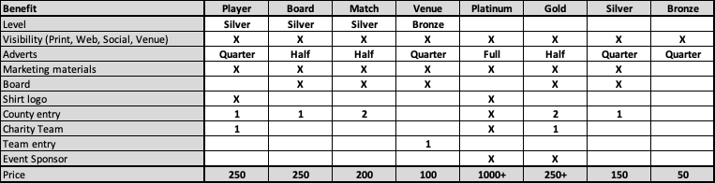

Benefits:

- Visibility: All sponsors are promoted on our digital Channels
- Adverts: Space in our match program
- Marketing materials: your materials will be available at all events
- Board: You get to keep the match board, signed by players.
- Entry: free entry to county matches
- Charity team: A team of County players to play who you choose and help raise money for your chosen charity.
- Event: Title sponsorship at one of our events.
- Board: like a Tee sponsorship in golf

Bundles:

- Boards: X4 county practice boards. Also event boards at a lower cost.
- Players: X50 support a top player for the season
- Program: Pay for the programs for the season and get gold + Full back cover Ad (400)
- Match: X5 be the event sponsor for a home county match

Mix and match any of these as works best for you.

